**Outdoor Billboard 2 – Solar Farm**

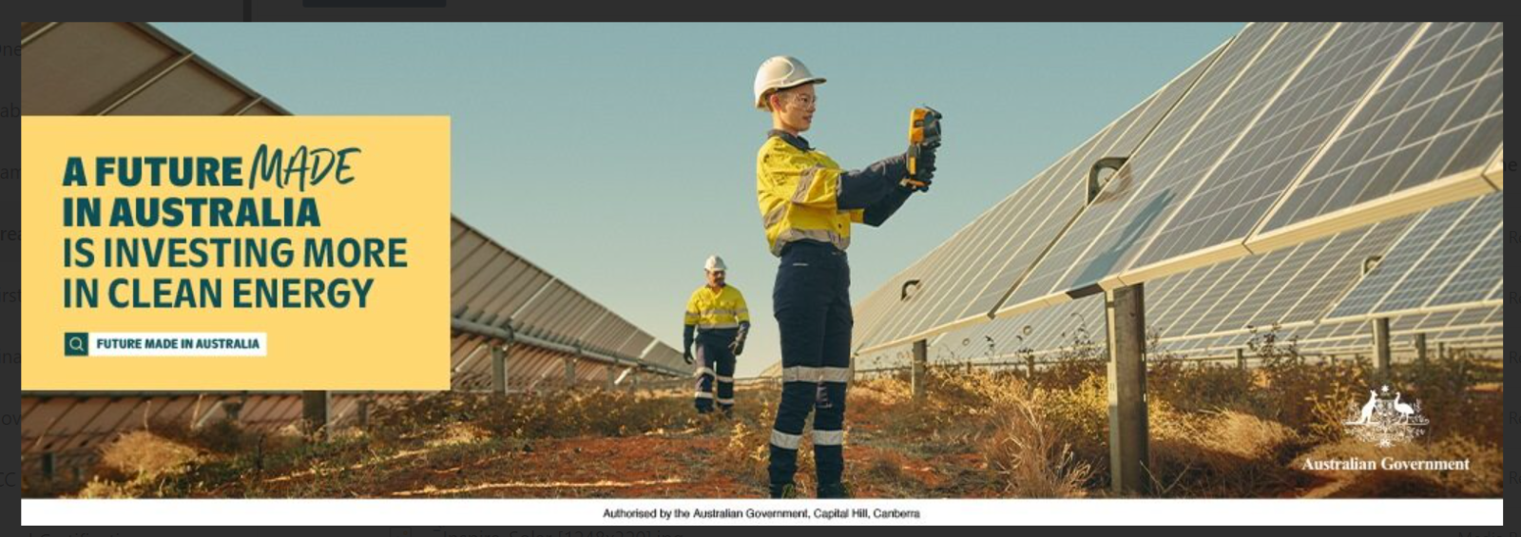

A landscape orientation outdoor billboard poster featuring copy and a coloured photograph.

The copy is housed in a yellow copy box on the left-hand side with the following copy in a dark green colour:

*A future made in Australia is investing more in clean energy*

A search icon is displayed next to the copy “*Future Made in Australia*”.

The photograph is of an outdoor solar farm with a blue sky, red dirt on the group and brown and green shrubbery growing out of it. The solar farm includes:

* Rows of solar panels. The photograph is taken at eye level in between two rows of solar panels that are tracking to the background of the image. There are more rows of solar panels in the peripheral right.
* In between two rows of solar panels are two workers, a female in the foreground holding a solar panel testing tool and a man in the far background. Both are wearing work wear – white hard hats, yellow button up shirts, navy- blue gloves and navy-blue pants and work boots.

The poster has the Australia Government crest in the bottom right-hand corner.

The poster has the following copy along the base “Authorised by the Australian Government, Capital Hill, Canberra”.