**Outdoor Posters – 3 – Resourcing Australia’s Prosperity**

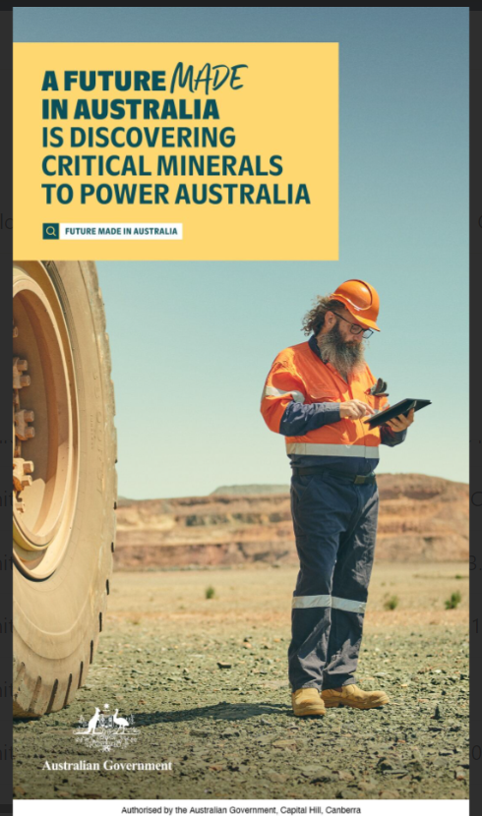

A portrait orientation outdoor poster featuring copy and a coloured photograph.

The copy is housed in a yellow copy box on the top left-hand side with the following copy in a dark green colour:

*A future made in Australia is discovering critical minerals to power Australia*

A search icon is displayed next to the copy “*Future Made in Australia*”.

The photograph is of a mining site with a blue sky. The mining site includes:

* In the foreground to the left-hand side, a large haul truck wheel.
* Of centre to the right, a middle-aged man with glasses and a beard wearing high vis work wear. He is wearing an orange hard hat, orange button up shirt and navy-blue work pants and work boots holding a digital tablet.

The poster has the Australia Government crest in the bottom left-hand corner.

The poster has the following copy along the base “Authorised by the Australian Government, Capital Hill, Canberra”.