**Outdoor Posters – 1 – NEAP**

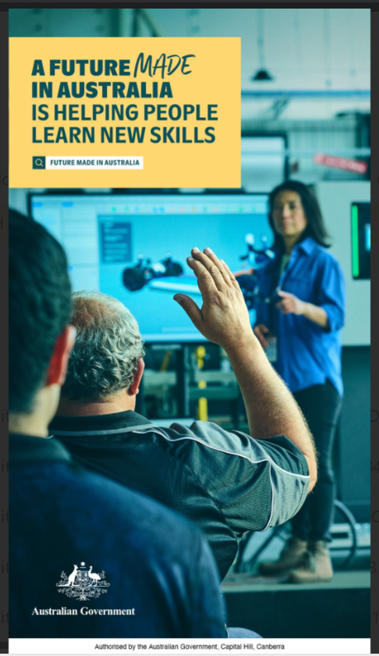

A portrait orientation outdoor poster featuring copy and a coloured photograph.

The copy is housed in a yellow copy box on the top left-hand corner with the following copy in a dark green colour:

*A future made in Australia is helping people learn new skills*

A search icon is displayed next to the copy “*Future Made in Australia*”.

The photograph is of a modern looking classroom for tertiary students (e.g. TAFE). The photograph is taken from the aspect of students at the back of the classroom. The classroom includes:

* A female teacher standing at the front of the class pointing to a learning screen that has an image of an electric vehicle on it.
* Sitting at the front of the class is a mature aged male student who has grey hair, putting up his hand to ask a question.
* Sitting at the back of the class is another male student.

The poster has the Australia Government crest in the bottom left-hand corner.

The poster has the following copy along the base “Authorised by the Australian Government, Capital Hill, Canberra”.