**Outdoor Posters – 2 – Building Women’s Careers**

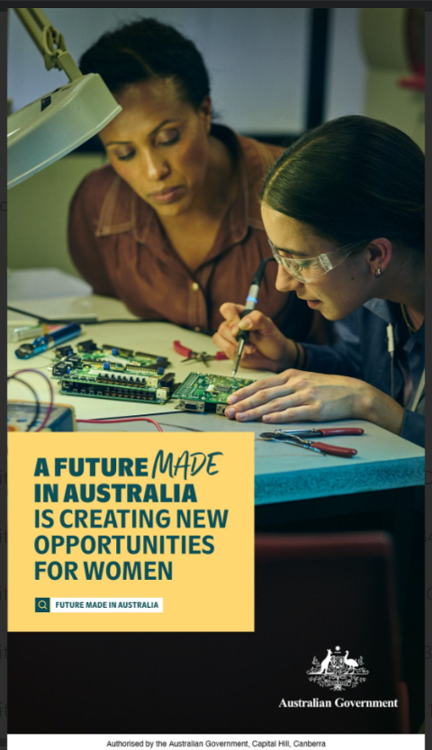

A portrait orientation outdoor poster featuring copy and a coloured photograph.

The copy is housed in a yellow copy box on the bottom left-hand corner with the following copy in a dark green colour:

*A future made in Australia is creating new opportunities for women*

A search icon is displayed next to the copy “*Future Made in Australia*”.

The photograph is of two women soldering a computer board at a table.

The first female is watching on. She is wearing a brown buttoned up shirt, and have olive skin and black hair.

The second female is soldering the computer board. She is wearing protective eyewear and a blue shirt.

The table they are sitting at has plyers and other computer boards scattered on it.

The poster has the Australia Government crest in the bottom right-hand corner.

The poster has the following copy along the base “Authorised by the Australian Government, Capital Hill, Canberra”.